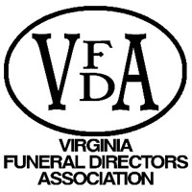

FOR IMMEDIATE ACTION BY
VFDA MEMBERS AND EMPLOYEES
2021 General Assembly Session

STEPS TO ADVOCACY FOR THE FUNERAL SERVICE PROFESSION

- Who is my legislator? (https://whosmy.virginiageneralassembly.gov/)
  - Click on the hyperlink or the link in parenthesis, which will take you here:

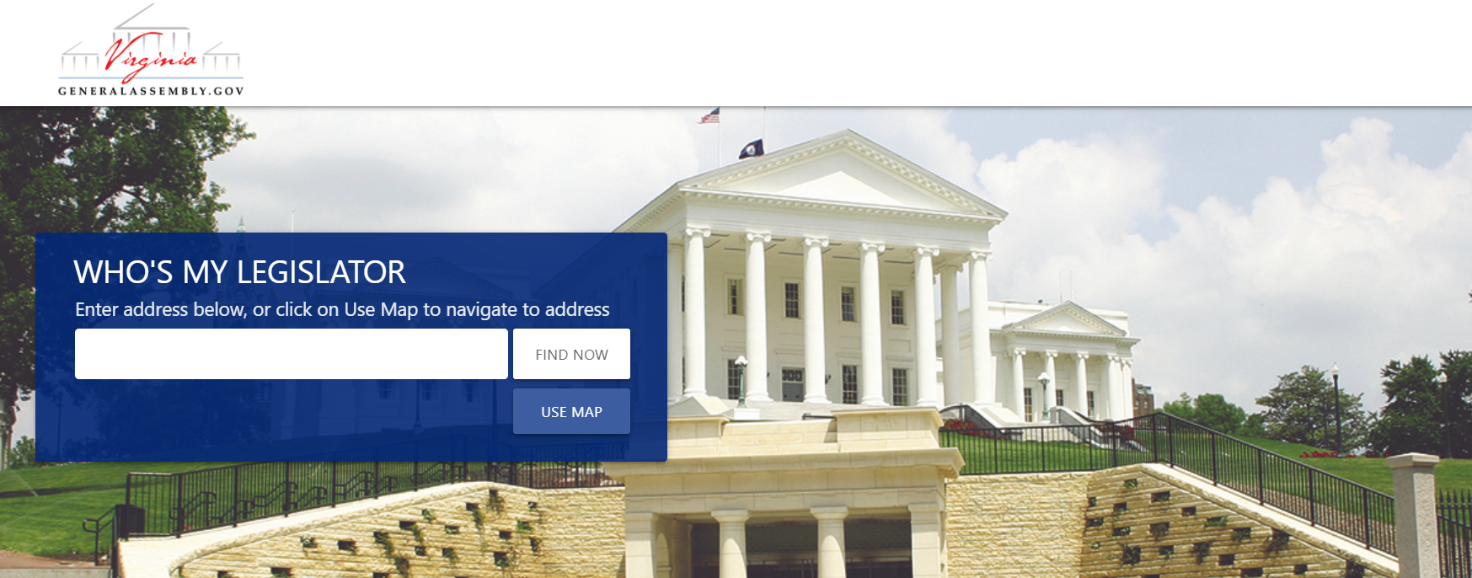

  - Fill in the box with:
    - Your home address; and
    - The address of your funeral service establishment(s)

  - Copy the information for each address you put in that is listed as the “State Delegate” and the “State Senator”. These are the people who represent you at home and where your business(es) are located. These are the first legislators you will put in the “TO” line on your email because they represent you.

***The importance of this is that you are a constituent for ALL the legislators who show up for each address. The legislators who pop up may be the same for both home and business for some of you, but please check to be sure!

Example: The first figure placed in the box was a work address, the second figure was a home address. In this case, there is constituency with four legislators.

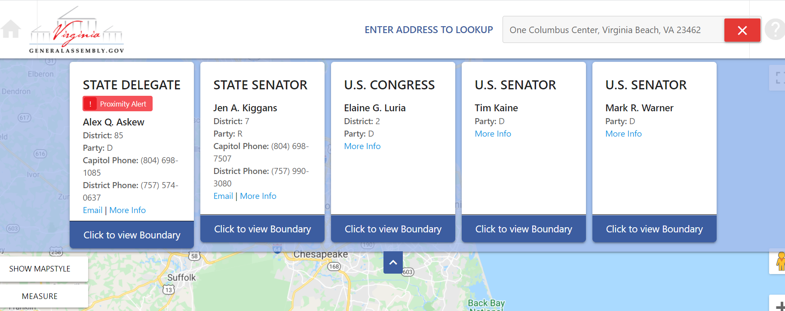
Figure 1

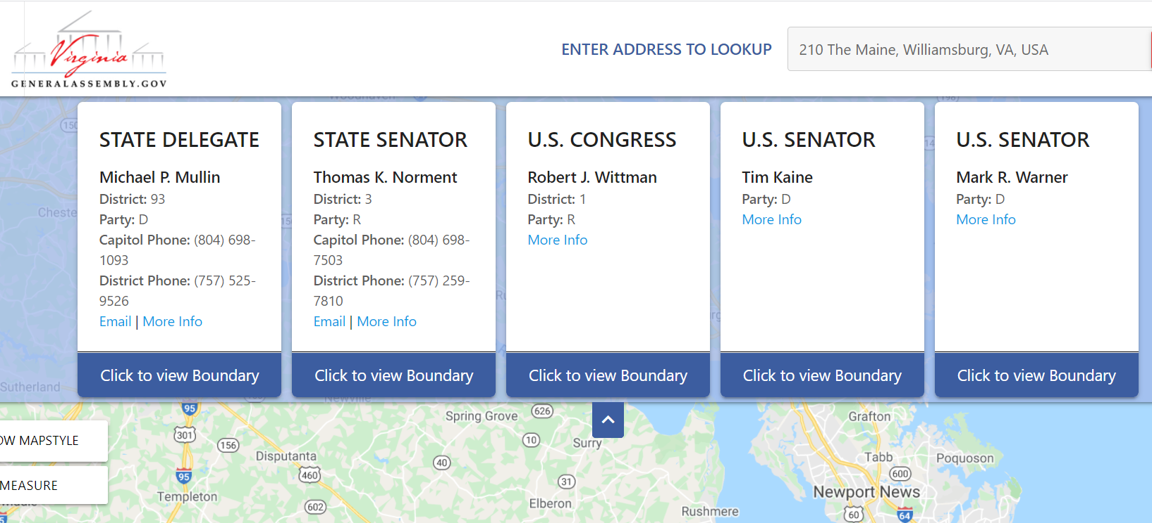
Figure 2

- Addressing your email – in what will be a chaotic session for legislators, advocates, and citizens alike, it is very important you identify yourself as a constituent immediately. You should also show “proof of constituency” at the start of the email.

Many offices will not review emails from or respond to non-constituents during the legislative session.

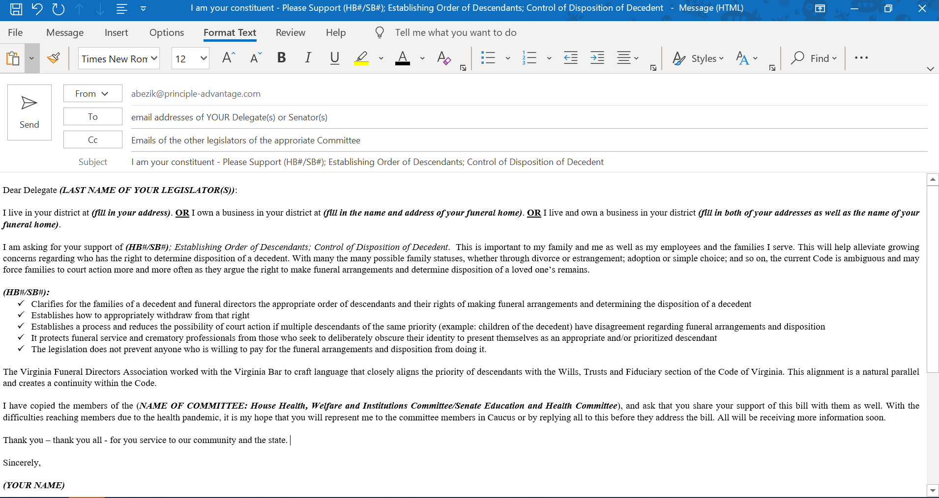

- After sending the emails - please go to your “SENT” box and forward them to Lacy Whittaker so we can document outreach and share with our patrons and the legislators as well. Also, please send any responses you receive to Lacy.

- Phone Calls - If you have a personal relationship with the legislators who represent you, (or any other legislator(s)) please also call them directly. Even if you leave a voice mail on their mobile phone, (or whatever number you typically would call), you should state your support of the bill number(s) and a brief description of what they are. Additionally, you should let the legislator know that you have also sent an email detailing your position, ask for their support and ask that they let the committee members know they support it as well. (They do have caucus meetings and can simply do a reply all to your email – even if they remove you – to ask for their support.)

The Messaging for Next of-Kin
What to Say in Your Email and Phone Call

HB# Establishing Order of Descendants; Control of Disposition of Decedent (VFDA commonly calls this the Next-of-Kin legislation)
House Committee Email – we anticipate this will again be referred to the Health, Welfare and Institutions (HWI) Committee; however, the Speaker may refer to any committee she deems appropriate. (This may mean courts.)
The following are the emails for those members, which includes our House patron, Delegate Mark Sickles (who is also the Chairman). Your Delegate(s) will go in first, then the members of the committee. You can cut and paste these into the “TO” or “CC” line of your email.
HWI COMMITTEE MEMBERS:
DelMSickles@House.Virginia.gov; DelSRasoul@House.Virginia.gov; DelPHope@House.Virginia.gov; DelCPrice@House.Virginia.gov; DelMLevine@House.Virginia.gov; DelLAird@House.Virginia.gov; DelCHayes@House.Virginia.gov; DelDAdams@House.Virginia.gov; DelEGuzman@House.Virginia.gov; DelKDelaney@House.Virginia.gov; DelKTran@House.Virginia.gov; DelISamirah@House.Virginia.gov; DelRWillett@House.Virginia.gov; DelBOrrock@House.Virginia.gov; DelRBell@House.Virginia.gov; DelJEdmunds@House.Virginia.gov; DelRRobinson@House.Virginia.gov; DelKHodges@House.Virginia.gov; DelCHead@House.Virginia.gov; DelBFowler@House.Virginia.gov; DelWWalker@House.Virginia.gov; DelJAvoli@House.Virginia.gov
The email should read as follows, with your personal information filled in.
Dear Delegate (LAST NAME OF YOUR DELEGATE):
I live in your district at (fill in your address). OR I own a business in your district at (fill in the name and address of your funeral home). OR I live and own a business in your district (fill in both of your addresses as well as the name of your funeral home).
I am asking for your support of Delegate Sickles’ (HB#); Establishing Order of Descendants; Control of Disposition of Decedent. This is important to my family and me as well as my employees and the families I serve. This will help alleviate growing concerns regarding who has the right to determine disposition of a decedent. With many the many possible family statuses, whether through divorce or estrangement; adoption or simple choice; and so on, the current Code is ambiguous and may force families to court action more and more often as they argue the right to make funeral arrangements and determine disposition of a loved one’s remains.
(HB#):
- Clarifies for the families of a decedent and funeral directors the appropriate order of descendants and their rights of making funeral arrangements and determining the disposition of a decedent
- Establishes how to appropriately withdraw from that right
- Establishes a process and reduces the possibility of court action if multiple descendants of the same priority (example: children of the decedent) have disagreement regarding funeral arrangements and disposition
- It protects funeral service and crematory professionals from those who seek to deliberately obscure their identity to present themselves as an appropriate and/or prioritized descendant
- The legislation does not prevent anyone who is willing to pay for the funeral arrangements and disposition from doing it.

The Virginia Funeral Directors Association worked with the Virginia Bar to craft language that closely aligns the priority of descendants with the Wills, Trusts and Fiduciary section of the Code of Virginia. This alignment is a natural parallel and creates a continuity within the Code.

I have copied the members of the House Health, Welfare and Institutions Committee, and ask that you share your support of this bill with them as well. With the difficulties reaching members due to the health pandemic, it is my hope that you will represent me to the committee members in Caucus or by replying all to this before they address the bill. All will be receiving more information soon.
Thank you – thank you all - for you service to our community and the state.
Sincerely,
(YOUR NAME)

SB# Establishing Order of Descendants; Control of Disposition of Decedent
SENATE EDUCATION AND HEALTH COMMITTEE MEMBERS:
Members are: Chairwoman Louise Lucas; Senators Dick Saslaw; Janet Howell; Steve Newman; Mamie Locke; George Barker; Chap Petersen; John Cosgrove; Lynwood Lewis; Shiobhan Dunnavant; David Suetterlein; Mark Peake; John Edwards; Ghazala Hashmi.
The Email Addresses are:
District18@Senate.Virginia.gov; District35@Senate.Virginia.gov; District32@Senate.Virginia.gov; District23@Senate.Virginia.gov; District02@Senate.Virginia.gov; District39@Senate.Virginia.gov; District34@Senate.Virginia.gov; District14@Senate.Virginia.gov; District06@Senate.Virginia.gov; District12@Senate.Virginia.gov; District19@Senate.Virginia.gov; District22@Senate.Virginia.gov; District21@Senate.Virginia.gov; District10@Senate.Virginia.gov

MESSAGE FOR SENATE EMAIL BELOW
Dear Senator (LAST NAME OF YOUR SENATOR):
I live in your district at (fill in your address). OR I own a business in your district at (fill in the name and address of your funeral home). OR I live and own a business in your district (fill in both of your addresses as well as the name of your funeral home).
I am asking for your support of Senator Deeds’ (SB#); Establishing Order of Descendants; Control of Disposition of Decedent. This is important to my family and me as well as my employees and the families I serve. This will help alleviate growing concerns regarding who has the right to determine disposition of a decedent. With many the many possible family statuses, whether through divorce or estrangement; adoption or simple choice; and so on, the current Code is ambiguous and may force families to court action more and more often as they argue the right to make funeral arrangements and determine disposition of a loved one’s remains.
(SB#):
- Clarifies for the families of a decedent and funeral directors the appropriate order of descendants and their rights of making funeral arrangements and determining the disposition of a decedent

- Establishes how to appropriately withdraw from that right

- Establishes a process and reduces the possibility of court action if multiple descendants of the same priority (example: children of the decedent) have disagreement regarding funeral arrangements and disposition

- It protects funeral service and crematory professionals from those who seek to deliberately obscure their identity to present themselves as an appropriate and/or prioritized descendant

- The legislation does not prevent anyone who is willing to pay for the funeral arrangements and disposition from doing it.

The Virginia Funeral Directors Association worked with the Virginia Bar to craft language that closely aligns the priority of descendants with the Wills, Trusts and Fiduciary section of the Code of Virginia. This alignment is a natural parallel and creates a continuity within the Code.

I have copied the members of the Senate Education and Health Committee and ask that you share your support of this bill with them as well. With the difficulties reaching members due to the health pandemic, it is my hope that you will represent me to the committee members in Caucus or by replying all to this before they address the bill. All will be receiving more information soon.
Thank you – thank you all - for you service to our community and the state.
Sincerely,
(YOUR NAME)

The emails would look similar to this:

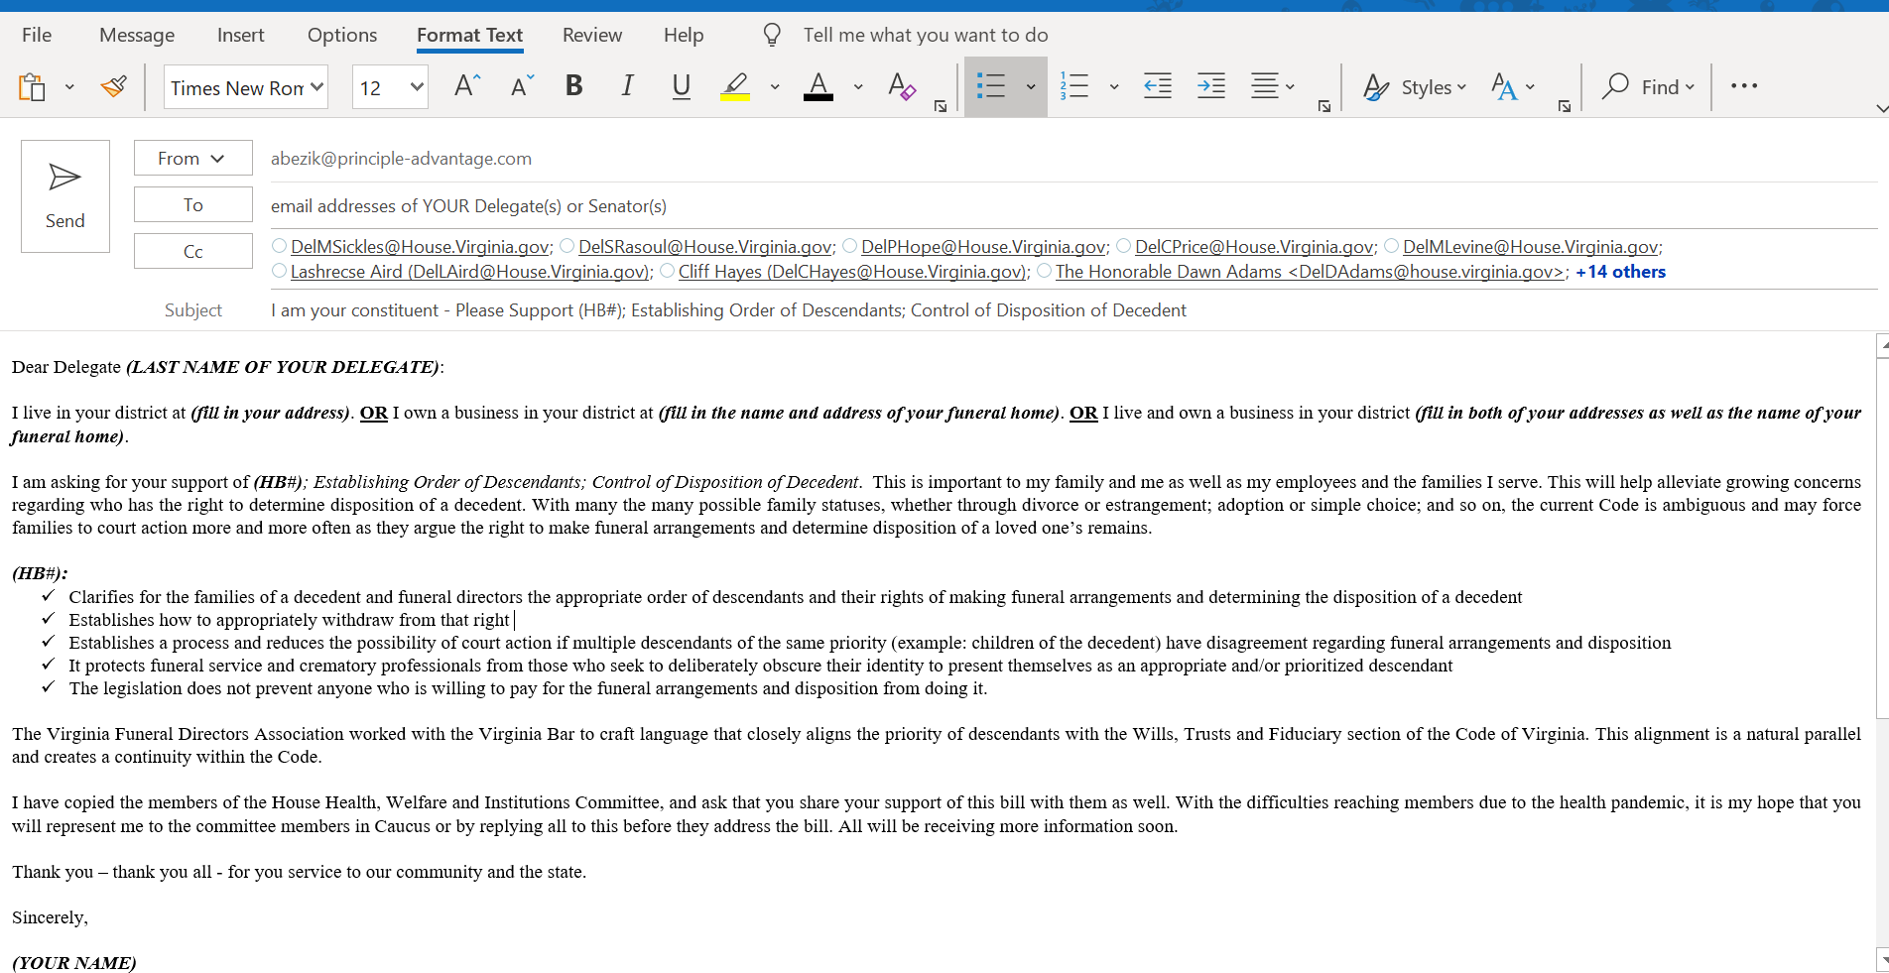

If emailing as an employee, change the start of the email to:
I live in your district at (fill in your address). OR I work at a business in your district at (fill in the name and address of the funeral home). OR I live and work at a business in your district (fill in both of your addresses as well as the name of the funeral home).
I am asking for your support of (Delegate Sickles’ HB#/Senator Deeds’ SB#); Establishing Order of Descendants; Control of Disposition of Decedent. This is important to the funeral home I work for, the families we serve and my family and me.

When phoning the legislators’ offices, whether someone answers the phone or you leave a message, give:
- Your name and address
- Say you are a constituent
- Ask for support of the Bill number
- Say it is important to your funeral home and the families you serve
- Say you have sent an email detailing the legislation
- Ask for the legislator(s)’ support

The Messaging for Manager of Record
What to Say in Your Email and Phone Call

HB#; Manager of Record for Funeral Service Establishments
Dear Delegate (LAST NAME OF YOUR DELEGATE):
I live in your district at (fill in your address). OR I own a business in your district at (fill in the name and address of your funeral home). OR I live and own a business in your district (fill in both of your addresses as well as the name of your funeral home).
I am asking for your support of Senator Cosgrove’s (SB#), which establishes requirements for becoming a Manager of Record for funeral service establishments.
Legislation during the 2020 regular session required the Board of Funeral Directors and Embalmers to reconstitute the funeral director-only license and the embalmer-only license and fast-tracked the regulatory process to make the licenses available by January 14, 2021.
There are few funeral director-only licensees left from the 1970’s. The VFDA was informed by Board staff that:
- Combined licenses (Funeral Service Licensee) were issued beginning January 1, 1973
- Per Board records, the last embalmer-only license appears to have been issued in May 1971
- Some funeral director-only licenses have issue dates as late as May of 1975, but the Board indicated to VFDA that they may have been issued as reinstatements or reactivations (so the issue date may have been "reset")
- Fewer than a dozen funeral director-only licensees serve as Managers of Record today

Funeral Service Licensees have been trained in every aspect of running a funeral service establishment (funeral home) from working with families to prepare the arrangements for their loved ones, to embalming. Embalming is a science, and many things can and have gone wrong.
What VFDA and I feel was not addressed as well as we thought it should be was the Manager of Record concern.

We feel strongly that requiring a Funeral Service Licensee be the Manager of Record at funeral service establishments that:
- Offer embalming as a service in the facility at which the funeral arrangements are performed
- Or offer embalming services off-site from where the funeral arrangements are performed and include it as required on the Itemized Statement of Funeral Goods and Services Selected form
Additionally, the VFDA and I believe that the following should be exempted from being required to have a Funeral Service Licensee as a Manager of Record:
- Those funeral director-only licensees who have had their licenses since 1975 or before, and are currently a Manager of Record, should be exempted from that requirement
- Those funeral homes that do not offer embalming services
(SB#):
- Requires appropriate education for a Manager of Record for funeral service establishments that offer embalming whether within or outside of the facility

- Exempts and protects those who have had their licenses since the 1970’s and are currently Managers of Record

- Allows a funeral director-only licensee to become a Manager of Record for a licensed funeral service establishment that does not offer embalming either within or outside of the facility

I have copied the members of the House Health, Welfare and Institutions Committee and ask that you share your support of this bill with them as well. With the difficulties reaching members due to the health pandemic, it is my hope that you will represent me to the committee members in Caucus or by replying all to this before they address the bill. All will be receiving more information soon.
Thank you – thank you all - for you service to our community and the state.
Sincerely,
(YOUR NAME)

SB#; Manager of Record for Funeral Service Establishments
Dear Senator (LAST NAME OF YOUR SENATOR):
I live in your district at (fill in your address). OR I own a business in your district at (fill in the name and address of your funeral home). OR I live and own a business in your district (fill in both of your addresses as well as the name of your funeral home).
I am asking for your support of Senator Cosgrove’s (SB#), which establishes requirements for becoming a Manager of Record for funeral service establishments.
Legislation during the 2020 regular session required the Board of Funeral Directors and Embalmers to reconstitute the funeral director-only license and the embalmer-only license and fast-tracked the regulatory process to make the licenses available by January 14, 2021.
There are few funeral director-only licensees left from the 1970’s. The VFDA was informed by Board staff that:
- Combined licenses (Funeral Service Licensee) were issued beginning January 1, 1973
- Per Board records, the last embalmer-only license appears to have been issued in May 1971
- Some funeral director-only licenses have issue dates as late as May of 1975, but the Board indicated to VFDA that they may have been issued as reinstatements or reactivations (so the issue date may have been "reset")
- Fewer than a dozen funeral director-only licensees serve as Managers of Record today

Funeral Service Licensees have been trained in every aspect of running a funeral service establishment (funeral home) from working with families to prepare the arrangements for their loved ones, to embalming. Embalming is a science, and many things can and have gone wrong.
What VFDA and I feel was not addressed as well as we thought it should be was the Manager of Record concern.

We feel strongly that requiring a Funeral Service Licensee be the Manager of Record at funeral service establishments that:
- Offer embalming as a service in the facility at which the funeral arrangements are performed
- Or offer embalming services off-site from where the funeral arrangements are performed and include it as required on the Itemized Statement of Funeral Goods and Services Selected form
Additionally, the VFDA and I believe that the following should be exempted from being required to have a Funeral Service Licensee as a Manager of Record:
- Those funeral director-only licensees who have had their licenses since 1975 or before, and are currently a Manager of Record, should be exempted from that requirement
- Those funeral homes that do not offer embalming services
(SB#):
- Requires appropriate education for a Manager of Record for funeral service establishments that offer embalming whether within or outside of the facility

- Exempts and protects those who have had their licenses since the 1970’s and are currently Managers of Record

- Allows a funeral director-only licensee to become a Manager of Record for a licensed funeral service establishment that does not offer embalming either within or outside of the facility

I have copied the members of the Senate Education and Health Committee and ask that you share your support of this bill with them as well. With the difficulties reaching members due to the health pandemic, it is my hope that you will represent me to the committee members in Caucus or by replying all to this before they address the bill. All will be receiving more information soon.
Thank you – thank you all - for you service to our community and the state.
Sincerely,
(YOUR NAME)

If emailing as an employee, change the start of the email to:
I live in your district at (fill in your address). OR I work at a business in your district at (fill in the name and address of the funeral home). OR I live and work at a business in your district (fill in both of your addresses as well as the name of the funeral home).
I am asking for your support of Senator Cosgrove’s SB#; Manager of Record for Funeral Service Establishments. This is important to the funeral home I work for, the families we serve and my family and me.

When phoning the legislators’ offices, whether someone answers the phone or you leave a message, give:
- Your name and address
- Say you are a constituent
- Ask for support of the Bill number
- Say it is important to your funeral home and the families you serve
- Say you have sent an email detailing the legislation
Ask for the legislator(s)’ support

VFDA MEMBERS: Please understand that you may be asked to reach out to legislators more than one time in what is sure to be another hectic, chaotic legislative session.

Thank you,

Marty White Lacy Whittaker Jay McIntyre, Chair
President Executive Director Legislative Committee

Your Advocacy Team: Angie Bezik; Cindy DiFranco; and Julia Hammond

