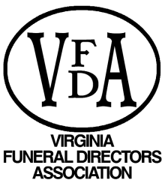
P.O. Box 395• Hanover, Virginia 23069•
Phone: (804) 264-0505 Fax: (804) 264-3260

October 5, 2017
Dear VFDA District Officers:
The Virginia Funeral Directors Association is calling for nominations for the following Board of Directors positions. To serve as a board member, your funeral home must be a member in good standing with the association. We ask that your district begin discussing this with your members at your next district meeting. All nominations are due to the VFDA office by March 1, 2018.
Available Position by District:
Southwest District, Second Vice President
Southwest District, 3 year board term
Blue Ridge District, 3 year board term
Shenandoah District, 3 year board term
Southside District, 3 year board term
At-Large Directors (2 year term, 2 vacancies available) – **All districts can submit names for the At-Large Directors positions**
Secretary-Treasurer - **All districts can submit names for the Secretary-Treasurer position**
Virginia Funeral Supply Association (1 year term)
If you have any questions regarding any of the VFDA Board of Directors vacancies or would like to serve, please feel free to contact the VFDA office (804) 264-0505.

