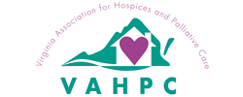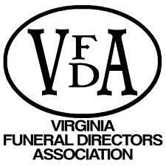

HOSPICE WORKSHOP
Objective:
Establish workshops for our regional hospice workers, staff and volunteers to promote and educate each other on how funeral service and hospice organizations can work together and understand each of our roles for the betterment of the families we serve.
Hospice team members will demonstrate an understanding of the processes and procedures commonly adopted by funeral homes after they transport the body of a hospice patient to their facility
Invite:
We invite you to a workshop on <date>, from <3 hour segment> at <location/address>. There will be periodic breaks and a certificate of completion will be provided for those that attend. Hospice nurses, social workers and volunteers are encouraged to participate.
Offer volunteers opportunity to receive their in-service.
Topics:
Talking about the Funeral: Information needed for the funeral home, the value of funeral service, a tour of the funeral home facilities. Q&A
The Transition: The transfer from Hospice to Funeral Home and a discussion on how we can help each other. Led by Hospice. Q&A
The Funeral Home: What happens once a family and the deceased client arrive, the funeral ceremony and the administrative process. Q&A
Contact Information:
Include a contact person and contact information.
Example Agenda for Day of Event (Honor a life well lived:
- Welcome and Introductions
- Reflect on the value of the funeral/memorial service
- Tour facilities (behind the scenes of the funeral home)
- Break for refreshments
- Q&A
- Transition from Hospice to a Funeral Service
- Q&A
- At the Funeral Home
  - Family Choices
  - Administrative
  - Useful Forms
    - Funeral Misconceptions by Alan D. Wolfet, Ph.D
    - Funeral Outline
    - Sample Death Certificate/Information on EDRS
    - Obituary Information
    - Appointment of Agent to Direct Disposition
    - Direction as to the Funeral and Disposition of the Principal
    - Reference Code 54.1-2825 Person to make arrangements for disposition of remains

- Q&A
- Close and present certificates

